Pizza Sales SQL Queries

KPI’s

1. Total Revenue

SELECT SUM(total_price) AS Total_Revenue

FROM pizza_sales



1. Average Order Value

SELECT

SUM(total_price) / COUNT(DISTINCT(order_id)) AS Average_Order_Value

FROM pizza_sales



1. Total Pizza Sold

SELECT SUM(quantity) AS Total_Pizza_Sold

FROM pizza_sales



1. Total Orders

SELECT COUNT(DISTINCT(order_id)) AS Total_Orders

FROM pizza_sales



1. Average Pizzas Per Order

SELECT

CAST(CAST(SUM(quantity) AS DECIMAL(10,2)) /

CAST(COUNT(DISTINCT(order_id)) AS DECIMAL(10,2)) AS DECIMAL(10,2))

AS Average_Pizzas_Per_Order

FROM pizza_sales



Charts  
1. Daily Trend for Total Order

SELECT

DATENAME(DW, order_date) AS Order_Day

,COUNT(DISTINCT(order_id)) AS Total_Orders

FROM pizza_sales

GROUP BY DATENAME(DW, order_date) -- DW is day of week

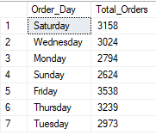

2. Hourly Trend for Total Orders

SELECT

DATEPART(HOUR, order_time) AS Order_Hours

,COUNT(DISTINCT(order_id)) AS Total_Orders

FROM pizza_sales

GROUP BY DATEPART(HOUR, order_time)

ORDER BY DATEPART(HOUR, order_time)

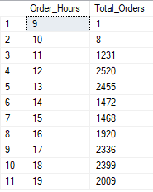

3. Percentage of Sales by Pizza Category

SELECT

pizza_category

,SUM(total_price) AS Total_Sales

,SUM(total_price) * 100 / (SELECT SUM(total_price) FROM pizza_sales)

AS Percentage_of_Sales_by_Pizza_Category

FROM pizza_sales

GROUP BY pizza_category

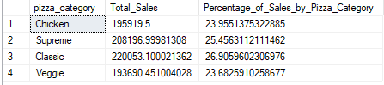

4. Percentage of Sales by Pizza Size

SELECT

pizza_size

,CAST(SUM(total_price) AS DECIMAL(10,2)) AS Total_Sales

,CAST(SUM(total_price) * 100 / (SELECT SUM(total_price) FROM pizza_sales) AS DECIMAL(10,2))

AS Percentage_of_Sales_by_Pizza_Size

FROM pizza_sales

GROUP BY pizza_size

ORDER BY Percentage_of_Sales_by_Pizza_Size DESC

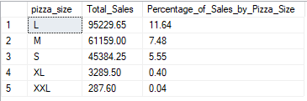

5. Total Pizzas Sold by Pizzaa Category

SELECT

pizza_category

,SUM(quantity) AS Total_Pizza_Sold

FROM pizza_sales

GROUP BY pizza_category

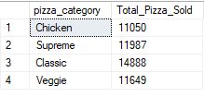

6. SELECT TOP 5

pizza_name

,SUM(quantity) AS Total_Pizza_Sold

FROM pizza_sales

GROUP BY pizza_name

ORDER BY Total_Pizza_Sold DESC

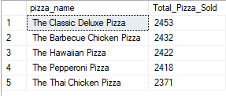

7. Bottom 5 Worst Sellers by Total Pizzas Sold

SELECT TOP 5

pizza_name

,SUM(quantity) AS Total_Pizza_Sold

FROM pizza_sales

GROUP BY pizza_name

ORDER BY Total_Pizza_Sold ASC

